- Compress and decompress a file using the gzip and gunzip command.

- gzip linux [ Compresses the file linux and create linux.gz ]
- gunzip linux [ Decompresses the gzip file and restores the original linux file ]

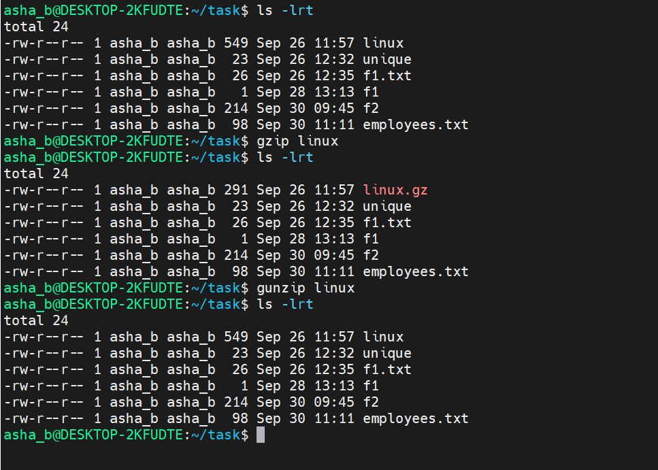
- Create a compressed tar archive containing multiple files, then view the archive contents.
- tar -zcvf file1.tar.gz f1.txt f1 employees.txt [ Create a compressed tar archive named file1.tar.gz containing f1.txt, f1, and employees.txt ]
- tar -ztvf file1.tar.gz [ Display the files stored inside the compressed tar archive ]
- tar -zxvf file1.tar.gz [ Extract the files from the compressed tar archive ]
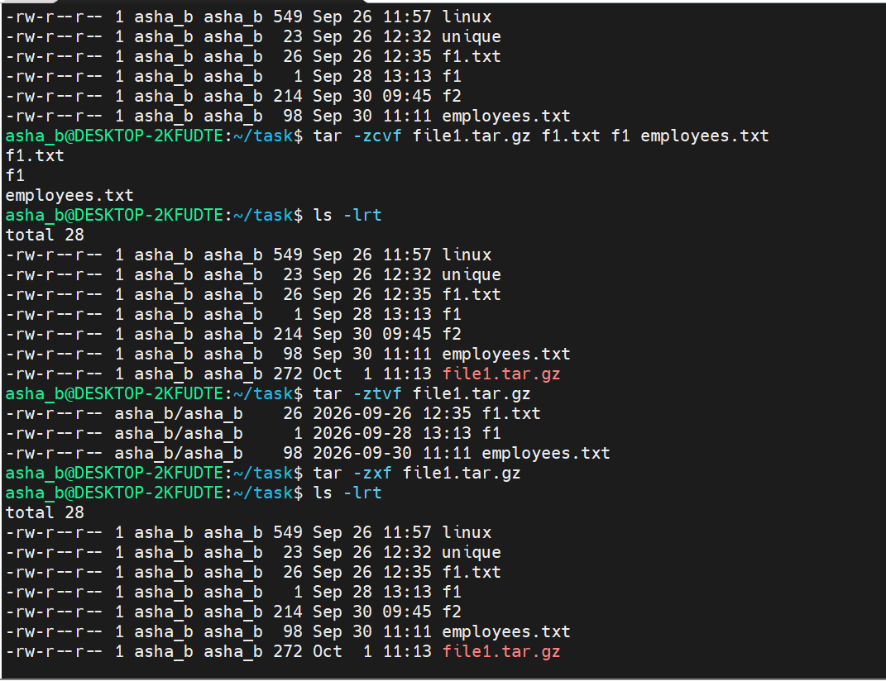
- Remove the original files and extract the files from the compressed tar archive.

- rm f1.txt f1 employees.txt [ Remove the original files f1.txt, f1, and employees.txt ]
- tar -ztvf file1.tar.gz [ Check and display the files available inside the archive ]
- tar -zxvf file1.tar.gz [ Extract the archived files back into the current directory ]
- ls -lrt [ List the files in the directory with details and shows the extracted files ]
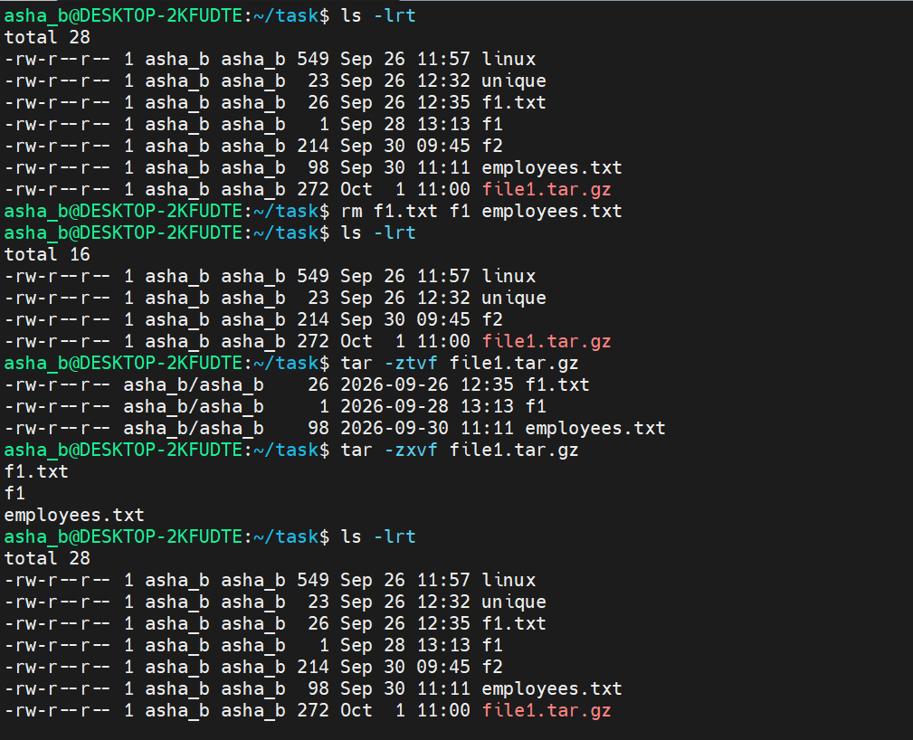
- Execute the sed command to search and replace the pattern.

- sed 's/^\<good\>/pleasant/1' f2 [ To search and replace the first occurrence of the whole word `good` in each line with `pleasant` ]
- sed 's/^\<good\>/pleasant/2' f2 [ To search and replace the second occurrence of the whole word `good` in each line with `pleasant` ]
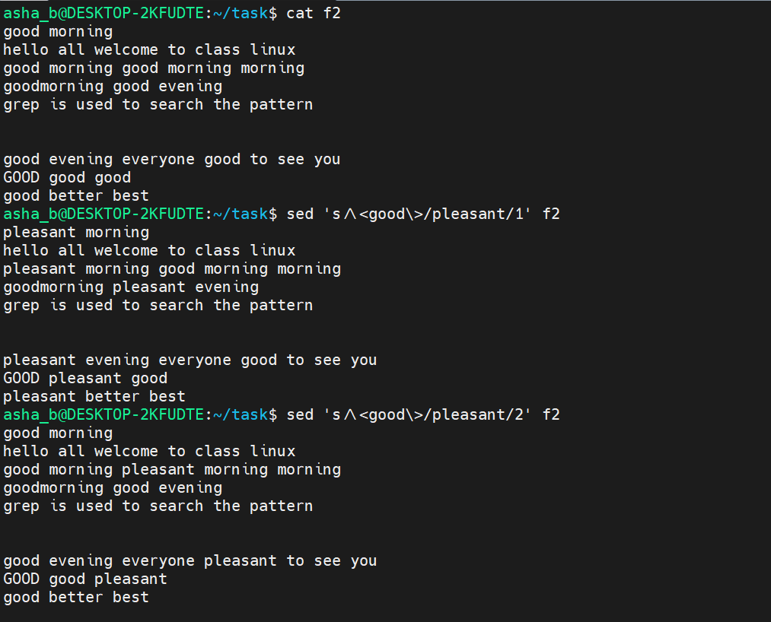
- sed 's/^\<good\>/pleasant/g' f2 [ To search and replace all the occurrences of the whole word `good` in each line with `pleasant` ]
- sed 's/^\<good\>/pleasant/gi' f2 [ To search and replace all the occurrences of the whole word `good` with `pleasant`, ignoring case ]
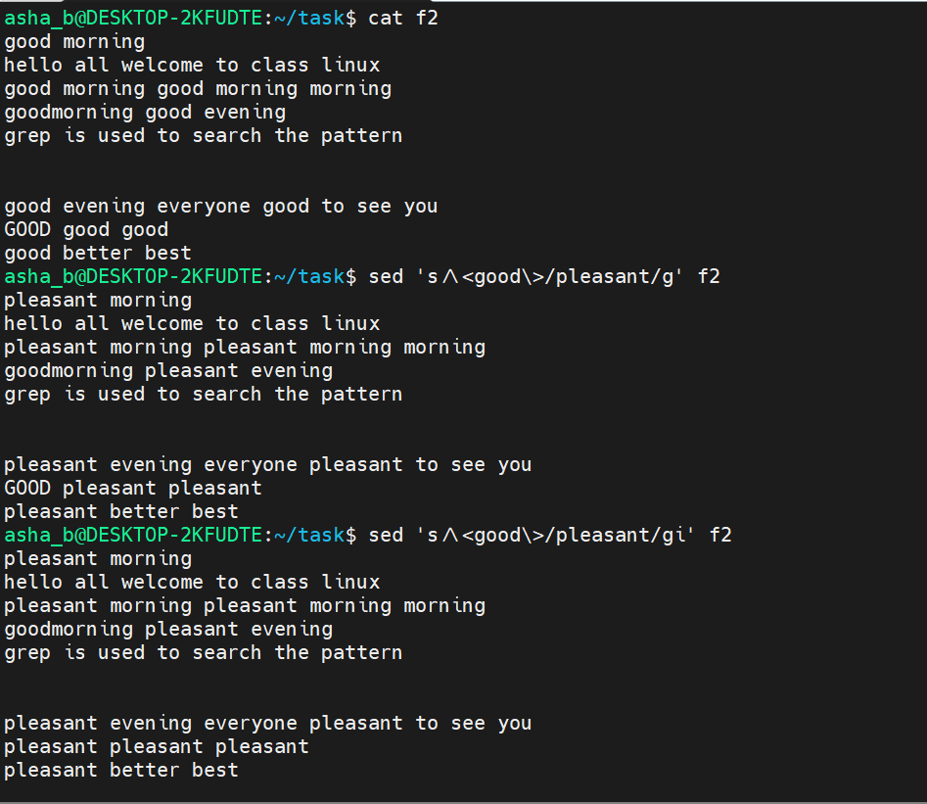

- sed '3s/morning/afternoon/2' f2 [ To search and replace the second occurrence of `morning` with `afternoon` on line 3 ]
- sed '3s/morning/afternoon/g' f2 [ To search and replace all the occurrences of `morning` with `afternoon` on line 3 ]
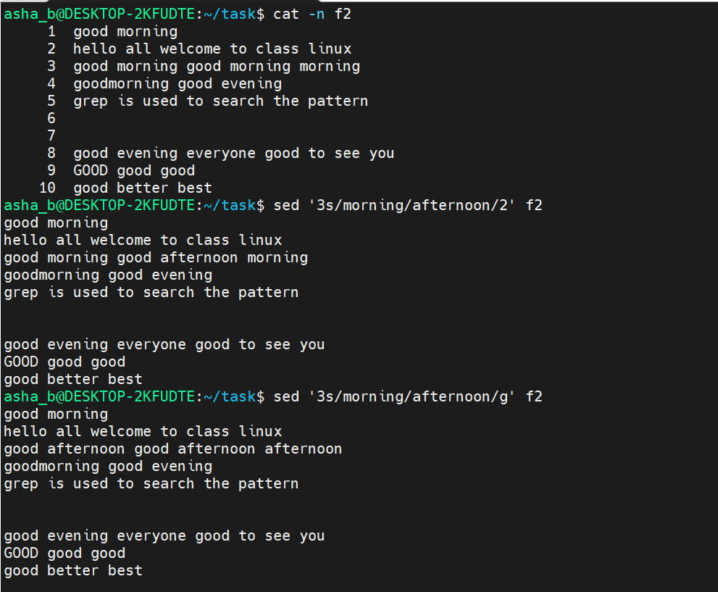

- sed '8s/everyone/good evening/' f2 [ To search and replace `everyone` with `good evening` on line 8 ]
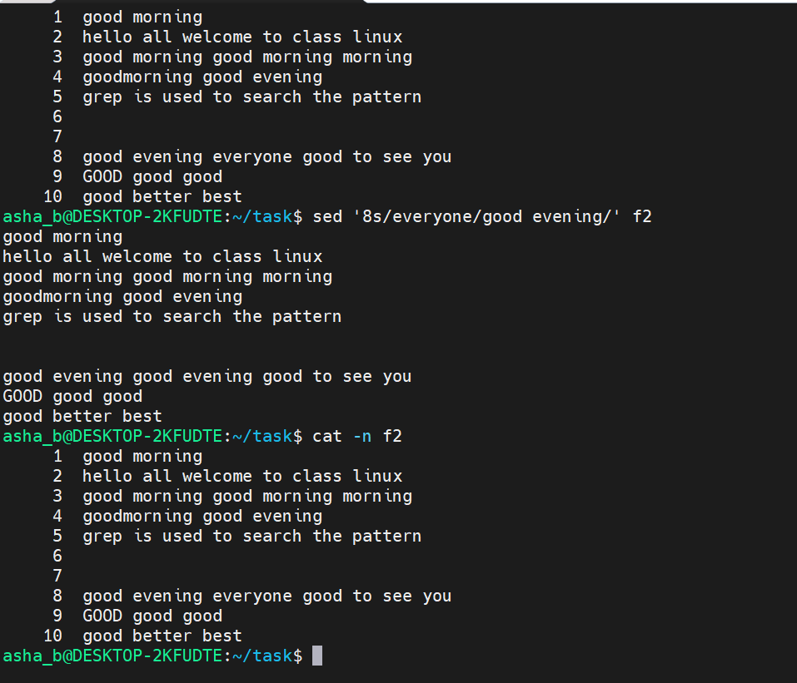

- sed -i '8s/everyone/good evening/' f2 [ To search and replace `everyone` with `good evening` on line 8 and update the file directly because of the flag -i ]
- cat -n f2 [ Display the updated contents of f2 with line numbers ]
